STATEMENT CONFIRMING RECEIPT

The undersigned, Ms. PurnaDivya Thuraga does hereby acknowledge receipt of the Labor Condition Application I-200-22165-279223 filed by Iconsoft, Inc. in connection with the H-1B visa petition filed by the company on her behalf.

IN WITNESS WHEREOF, the undersigned has executed this receipt as of the date set forth below.

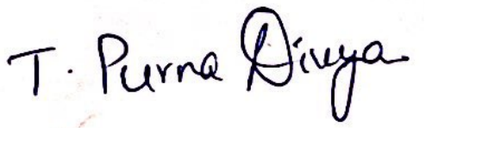
PurnaDivya Thuraga Date; 06/22/2022

